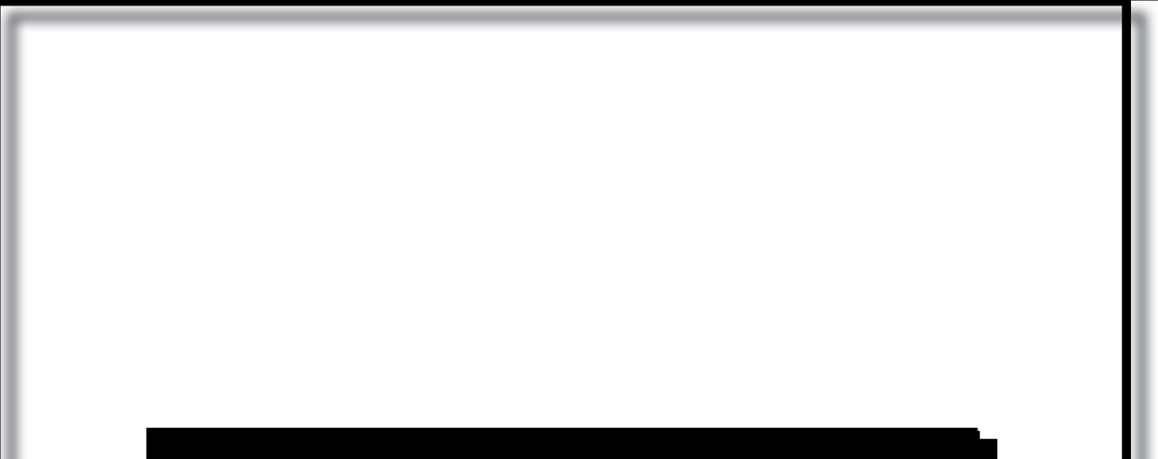





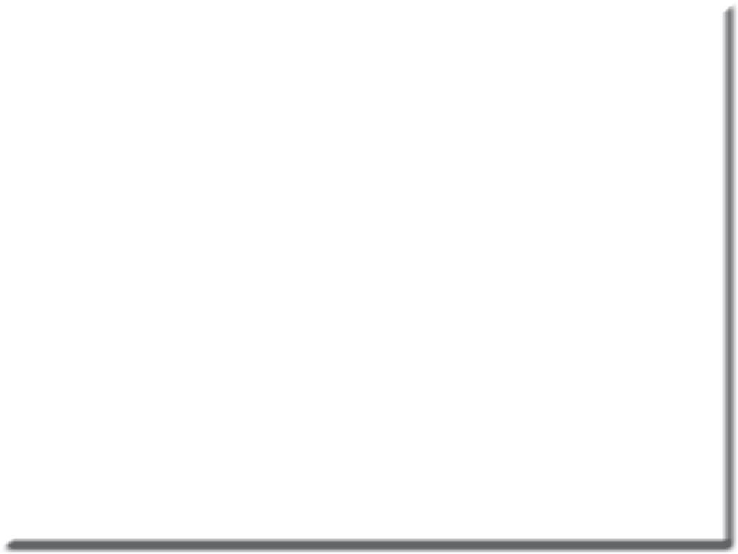



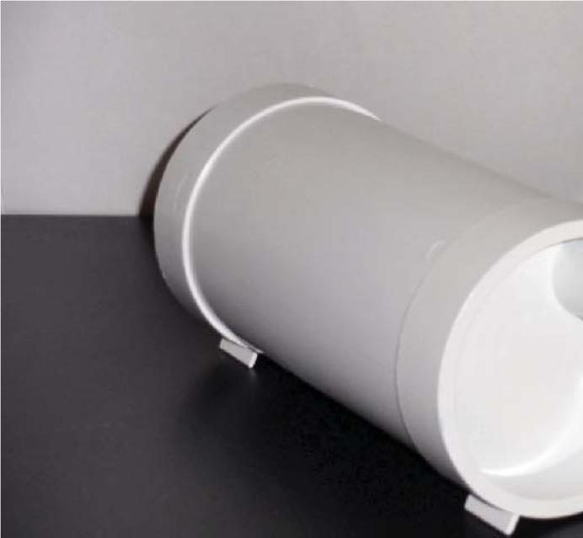
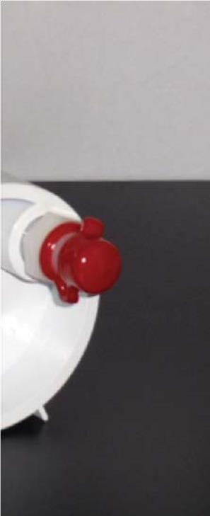


DD2011 Chairside Amalgam

Separator

IMPORTANT INFORMATION ABOUT SEPARATOR LIFE CAN
BE FOUND ON PAGE 7 OF MANUAL FAILURE TO FOLLOW
WILL VOID SEPARATOR WARRANTY

DDShgSolutions

Product Description and Specifications
The DD2011 disposable chairside amalgam separation system has been tested and passed the ISO 11143 protocol [ISO 1143:2008(E)]. The DD2011 is designated as a Type 3 amalgam separator. The maximum water flow rate is 1.0 liters per minute. The maximum fillable volume of the separator is calculated to be 360 ml. The separator is installed in the dental vacuum line (HVE line). A loss of suction will occur 3-7 days prior to the DD2011 becoming full and requiring replacement. The DD2011 needs to be changed when the air flow at the HVE tip is no longer adequate, which will be demonstrated by the noticeable decrease of suction. The decrease in suction is the gauge used to determine the necessary replacement of the unit. If the system is not replaced within 3-7 days after noticeable decrease of suction is noted and is allowed to fill completely, the unique design of the system will alarm you by shutting off completely, not allowing hazardous waste to flow past the unit.
The change out rate varies from 9 to 12 months and depends upon chair activity. The DD2011 is designed to handle a Standard dental vacuum of 7 inches of Hg. Instructions for changing the amalgam separator are found at the end of the manual. Installation
Installation of the chairside amalgam separator varies as a function of dental chair design. Photographs of typical installations are shown below and may be a useful guide. The separator is placed under the dental chair and spliced in line with the high-volume evacuation lines. The unit ships with 1/2, 5/8, and 1 inch nylon hose barb fittings. The separator has two NPT ports: one is the “inlet” port and is located “off axis”. The second port is the discharge and is located in the center axis of the separator. It is important to have the “inlet” port connected to the HVE tip (i.e. coming from the patient) and the “outlet” Port connected to the vacuum source (dental vacuum pump) In many dental chairs, the vacuum hose is “snaked” inside the chair and subject to sharp bends which limit the air flow through the hose. A short direct connection from the floor to the separator improves air flow and prevents debris and prevents debris from clogging the lines.
It is recommended that the chairside trap remains in use. The trap prevents large pieces of debris from clogging the lines.
The Department of Defense Medical Military Facilities Design and Construction Criteria (Military Handbook-1191) calls for the following dental vacuum system operating criteria to be met:
21 to 27 kPa (6 to 8 in-Hg) with a minimum vacuum of 21 kPa (6 in-Hg) to be maintained at the farthest HVE inlet
A flow rate of 3.3 liters/second (7 standard cubic feet per minute).

Amalgam Waste Recycling Issues
Contact your local environmental specialist prior to disposal of any mercury containing hazardous waste
Although mercury in the form of dental amalgam is very stable, amalgam should not be disposed of in the garbage, infectious waste “red bag,” or sharps container. Mercury containing amalgam waste generated in the dental operatory can on occasion meet the requirement of hazardous waste. Amalgam should not be rinsed down the drain. Some communities incinerate municipal garbage, medical waste, and sludge from wastewater treatment plants. If amalgam waste ends up being incinerated mercury vapor can be released to the environment due to the high temperatures used in the incineration proce


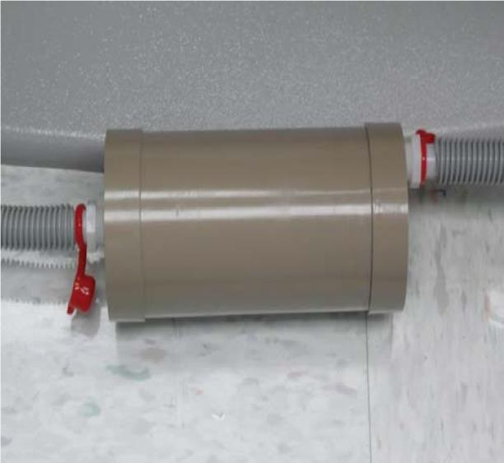

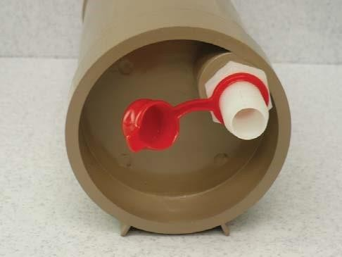
The DD2011 amalgam separator was installed on a Dental EZ chair. The unit is placed on the floor next to the chair. It can be located inside the floor mounted junction box if space permits. The unit shown here is placed at the side of the chair but can be moved to any location that is convenient. The unit shown here has the 5/8-inch nylon hose barb fittings with red vinyl caps. For some installations, the HVE hose may have to be relocated outside the chair. Velcro® fasteners can be used to mount the unit to the dental chair, keeping the unit off the floor.
The photograph at the left shows the inflow side of DD2011. Note that the inflow port is “off axis”. This side of the separator is connected to the HVE line coming from the patient. Note the red vinyl cover over the 5/8-inch inflow port of the separator. When the separator is loaded with debris and needs changing, the red vinyl cover is placed over the port to prevent any leakage of debris from the separator.

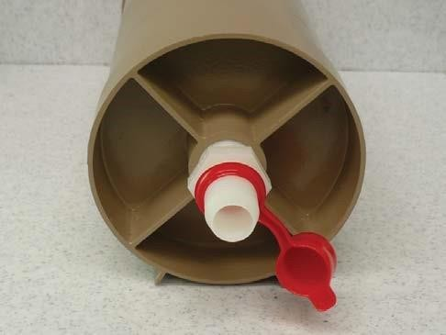
The photograph on the left shows the outflow side of DD2011. Note that the outflow port is in line with the long axis of the separator. This side of the separator is connected to the vacuum source. Note the red vinyl cover over the 5/8-inch outflow port of the separator. When the separator is loaded with debris and needs changing, the red vinyl cover is placed over the port to prevent any leakage of debris from the separator.

Recycling Program
The American Dental Association Best Management Practices (BMPs) recommends that all amalgam waste be recycled.

Vacuum Line Cleaner Effects on Hg Levels in Dental Wastewater
Vacuum line cleaners are recommended by some manufacturers of dental vacuum systems to help keep the lines from clogging and to limit the formation of odors. The chemical makeup of line cleaners can have important effects on dissolved Hg levels in dental wastewater. Oxidizing line cleaners, especially chlorine containing products like sodium hypochlorite (bleach) can mobilize or dissolve Hg contained in amalgam particles found in vacuum lines. Oxidizing vacuum line cleaners should be avoided.

Vacuum Line Cleaners and Foam Production
Many different issues can affect the performance and endurance of dry dental vacuum systems. The use of vacuum line cleaners can have a profound effect on both dry vacuum pumps and on DD2011 amalgam separators. Foam producing line cleaners produce plaque-like deposits in vacuum lines and more significantly have been shown to damage dental vacuum pumps. Foam enters the dry vacuum pumps and over time causes the buildup of deposits that causes them to fail prematurely. Foam also causes the DD2011 amalgam separator to clog prematurely. For these reasons, the use of line cleaners that foam is not recommended. We recommend the use of PureVac (Sultan Chemists, Englewood, N.J.) as it does not mobilize Hg (to a significant extent) and does not foam to the point where it will damage vacuum pumps.

Air Flow Levels (Vacuum Quality) in Dental Units
The ability of the High-Volume Evacuator (HVE) to remove water and debris from the dental patient’s mouth is an important issue. Adequate suction levels are needed to safely remove water and debris from the patient’s oral cavity. A critical factor in HVE vacuum level is the diameter and geometry of the vacuum lines that run through the dental chair. Small diameter lines running a tortuous course can limit air flow and cause inadequate vacuum Right angle (90 degree) vacuum line fittings and “pinched” vacuum lines can substantially reduce air flow leading to inadequate HVE performance. For this reason, it is recommended that vacuum levels at the HVE tip be assessed prior to installation of the DD2011 amalgam separator. In some cases, rerouting the vacuum lines outside the chair may be needed to achieve adequate vacuum levels (before DD2011 is installed). We recommend the use of the Dental EZ Flowcheck™ vacuum gauge to measure chairside vacuum levels before and after installation of the filtration unit. The Flowcheck™ dental vacuum flow measurement device is available from Dental EZ Corporation.

http://www.dentalez.com/ramvac/accessories/flowcheck.html
There is a draft ISO standard for dental vacuum systems, ISO/PDTS 22595-1. The draft ISO standard calls for an air flow of at least 250 liters/minute (4.1 liters/second) at the HVE tip. Testing of the DD2011 chairside amalgam separator has demonstrated minimal impact on suction quality (0.1 inches of Hg)

Addendum
Prior to the installation of the DD2011 amalgam separator:
- Verify that the dental chair has an adequate vacuum level. Vacuum levels can be measured with a digital vacuum gauge at the HVE tip. A recommended vacuum gauge is the DentalEZ
Flowcheck™. More information at: http://www. dentalez.com/ramvac/accessories/flowcheck.html
- An alternative to the Flowcheck™ is the DentalEZ Vacheck™ which is a Pass/Fail device that fi ts into the HVE tip. Adequate vacuum will hold the device in the HVE when it is turned “upside down” More information on the Vacheck™ is available at: http://www.dentalez.com/ramvac/ accessories/vacheck.html
- Before taking vacuum measurements: install a new or “clean” chairside trap in dental chair. There may be several causes for inadequate vacuum levels:
  - 90 degree fittings on dental vacuum lines can severely impact air flow
  - kinked vacuum hoses
  - vacuum hoses plugged with debris
- To improve air flow, vacuum lines can be rerouted outside the dental unit to improve dental vacuum levels
- Once the vacuum levels have been verified as providing adequate air flow, the DD2011 can be installed. Vacuum levels should be re-measured and recorded in a logbook after the installation of the DD2011.
- Use an appropriate vacuum line cleaner to help maintain dental vacuum lines. We recommend the use of Purevac (Sultan Healthcare, Englewood, N.J.). Purevac is a non-foaming line cleaner that does not substantially mobilize mercury from amalgam.

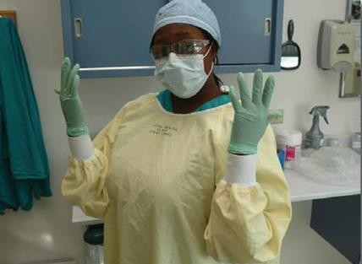
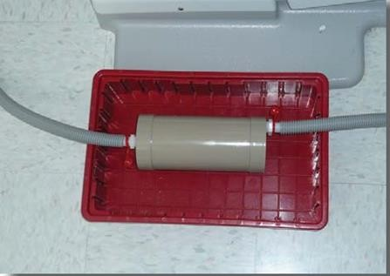
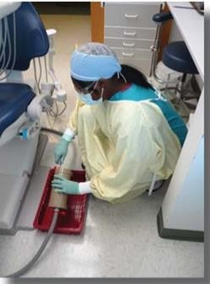
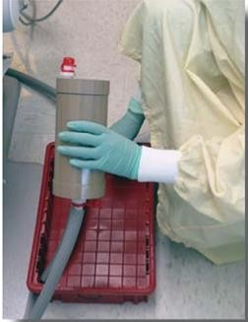
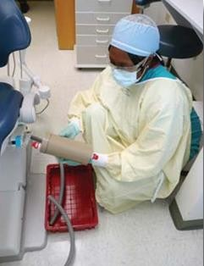
The inflow side of the amalgam separator is angled up at approximately 45 degrees and the vacuum hose is pulled off the inflow side off the inflow side barb. The end of the vacuum lines should be kept in the tray to trap any wastewater that may remain in the lines. Any wastewater that collects in the tray should be disposed of appropriately. DO NOT pour any of the wastewater down the drain as it may contain substantial amounts of mercury. The red vinyl cap is then placed over the inflow hose barb which seals this side of the amalgam separator. The amalgam separator is then angled at 45 degrees so that the outflow barb is pointed up and the process is repeated. The red vinyl cap securely placed on the outflow barb.
Always wear personal protective equipment when
changing or replacing the DD2011 Amalgam
Sepa-
rator. At a minimum the person changing the separa-
tor should wear gloves, protective eye wear, mask
and gown. Any remaining fluid in the separator
should be considered potentially infectious medical
waste.

The Chairside amalgam separator will need
to be
changed when vacuum levels fall below recom-
mended values (see the manual for additional de-
tails). The used amalgam separator (still connected
to the vacuum lines) should be
placed in a tray that
will collect any spilled wastewater, preventing it
from
m contacting the Operating floor.

Photograph showing the used amalgam separator disconnected from the vacuum lines. The red caps are securely placed on both ends and used amalgam separator is ready for recycling. A new DD2011 amalgam separa-
tor can now be installed by placing the vacuum hoses on the appropriate hose barb fittings
HOW TO AVOID PREMATURE AMALGAM SEPARATOR LIFE
- Never use on a hygienist chair. Cleaning compounds will clog amalgam separator with prophy paste, etc. Hygienist chairs have no hazardous materials and can go directly to sewer system.
- Do not use a foam producing line cleaner. Plaque-like deposits will build up and have been shown to damage dental vacuum pumps.
- We highly recommend a non-foaming liquid cleaner. Some granular and tablet cleaners do not break down and can cause premature amalgam separator life. 1 Liter maximum or manufacturers recommendation.
- It is very important not to use 90° fitting when installing amalgam separator. It will cause improper vacuum flow.
- Do not use granular or tablet cleaners in amalgam traps, it will cause premature amalgam separator failure.

DD2011 CHAIRSIDE AMALGAM SEPARATOR
- Verify suction lines have adequate vacuum prior to installation.
- Clean suction lines with line cleaner. Turn off vacuum pump before proceeding with the installation.
- Thread the included hose adapters into each inlet and outlet of separator housing. Teflon tape on threads is recommended. Attach flexible plastic cap plugs for recycling convenience.
- Cut the main suction line at a proper location for the separator.
- Connect the suction hose portion from the chair to the off-center (inlet) port of separator.
- Connect central (outlet) port of separator to the remaining suction hose leading to the junction box.
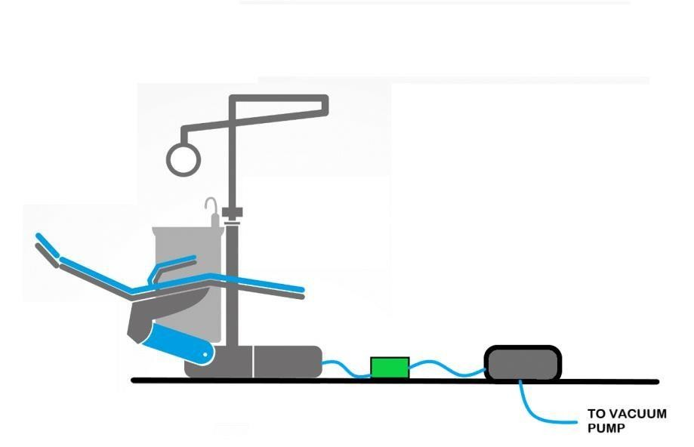
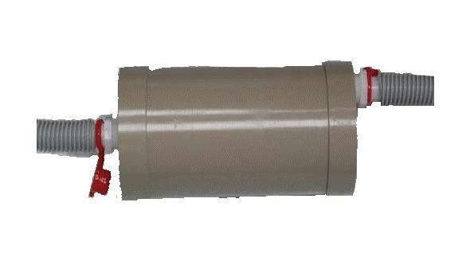










- Avoid sharp bends and elbows in the suction hoses which decrease line vacuum.
It is very important not
to use 90° fitting when
installing filter. It will
cause improper vacuum
flow

INSTALLATION SUMMARY

FROM CHAIR (INLET)

TO VACUUM

PUMP

(

OUTLET

)

TO VACUUM
PUMP

JUNCTION BOX

Hose Adapter

DENTAL

CHAIR

DD2011

- Turn on the vacuum pump to verify suction with separator installed.

IMPORTANT
- Hygiene procedures using polishing powders/prophy pastes clog the separator and must be avoided in operatories with the DD2011 separator installed.
- Use non-foaming, neutral pH (6-8) liquid line cleaners to maintain service life of the separator and reduce dissolved mercury. 1 liter maximum or manufacturers recommendation.
- Avoid sharp bends and elbows in the suction hoses which decrease line vacuum.

